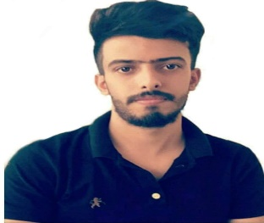

**Dhurgham Kadhim Qasim**

**Iraq/Baghdad**

**Date of Birth : 9/3/1996**

**Gender : Male**

**Mobile: 07711136822**

**Email:** [**dhurgham20kadhim@gmail.com**](mailto:dhurgham20kadhim@gmail.com)

**Professional Profile**

**Graduated from department of information and communications engineering**

**I can work independently using my own initiative or as part of a team.**

**I am looking to combine academic achievements and work experience in a challenging role within the voluntary sector.**

**Education and Qualifications**

**Information and communications engineering (University of Baghdad) 2018**

**Electrical, Electronic (1+2), Programing (C++, O O P), Mathematics, Auto CAD, IT, Logic, Microprocessors,**

**Micro controllers, CAD Design, Field & Propagation, Antenna, Eng. Analysis, Coding & Information Theory,**

**Data base (SQL), Networks design, Algorithm & Data structure, Information System Analysis & Design,**

**Cryptography, Digital Signal Processing, Digital System Design, Computer Architecture, Internet Architecture**

**Operating System, Fiber Optics, Analog Communication, Digital Communication, Satellite Communication.**

**Graduate Projects:**

**(Construct and design digital experimental kit)**

**Key I.T. Skills**

1. Work on Microsoft Office ( Word , Excel , Power point , project)

2. Use Auto CAD

3. Design electrical & electronic circuits by multism